Data Science is a study that deals with identification, illustration and extraction of meaningful info from data sources to be used for business functions.

With huge amount of facts creating each minute, the necessity to extract the valuable insights is a must for the industries to stand out from the crowd. Data Science engineers setup the database and data storage in order to facilitate the process of data mining, data mugging and other processes. Now a days, organization are running behind profits, but the businesses that express efficient approaches based on fresh and valuable visions always win the game in the long-term.

In reality, data science is developing rapidly and has already shown vast difference of opportunity that a wider definition is important to understanding it.

And whereas it's difficult to pin down a particular definition, it's quite simple to learn and feel its impact. Data science, once applied to different fields will result in unbelievable new insights. And therefore the people that are using it are already gaining the benefits.

**Lifecycle of Data Science**

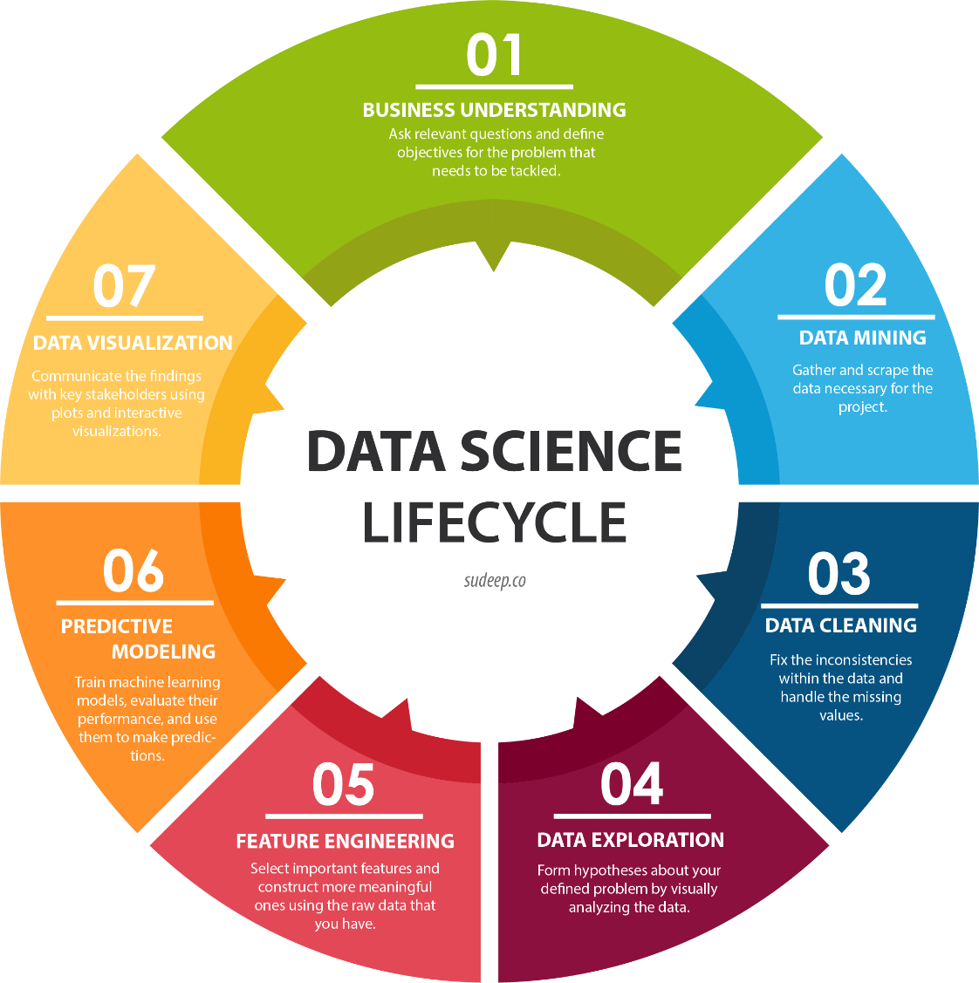

**Data Scientist roles and Responsibilities**

A data scientist is an expert responsible for gathering, analyzing and interpreting huge amounts of data to find ways to aid the business improve operations and increase a competitive edge over competitors.

The data scientist make use of advanced analytics technologies, including machine learning and predictive modeling, to provide insights beyond statistical analysis. The demand for data science skills has increased significantly in recent years as businesses look to collect useful data from the huge amounts of organized, unorganized and semi-organized data that a big organization produces and collects -- collectively referred to as big data.

A data scientist’s key duty is data analysis, a process that initiates with data collection and ends with business decisions made on the basis of the data scientist’s final data analytics results. Data scientists normally work in teams to mine big data for information that can be used to forecast customer behavior and find business hazards and opportunities.

These experts are tasked with evolving statistical learning models for data analysis and must have knowledge using statistical tools, as well as the capability to generate and evaluate complex predictive models.

**Business Intelligence (BI) vs. Data Science**

* Business Intelligence mainly analyzes the previous data to find hindsight and insight to define the business tendencies. Business Intelligence allows you to take data from external and internal sources, arrange it, run queries on it and create dashboards to answer the questions like quarterly profits analysis or business glitches. Business Intelligence can evaluate the influence of certain events in the near future.
* Data Science is a straight forward approach, an exploratory way with the focus on analyzing the previous or present data and forecasting the future results with the aim of making informed decisions. It responses the open-ended queries as to “what” and “how” events occur.